**EXP NO 6: DEMONSTRATE VIRTUALIZATION BY INSTALLING TYPE-2 HYPERVISOR IN YOUR DEVICE, CREATE AND CONFIGURE VM IMAGE WITH A HOST OPERATING SYSTEM (EITHER WINDOWS/LINUX).**

**DATE:**1.10.2025

**AIM:**

To demonstrate virtualization by installing type-2 hypervisor in your device, create and configure VM image with a host operating system (either windows/linux).

**PROCEDURE:**

STEP 1:Dowload VMware workstation and installed as type 2hypervisor.

STEP2:Dowload ubuntu or tiny OS as iso image file.

STEP 3: In VMware workstation->create new VM.

STEP 4: Do the basic configuration settings.

STEP 5: Created tiny OS virtual machine.

STEP 6: Launch the VM.

**IMPLEMENTATION:**

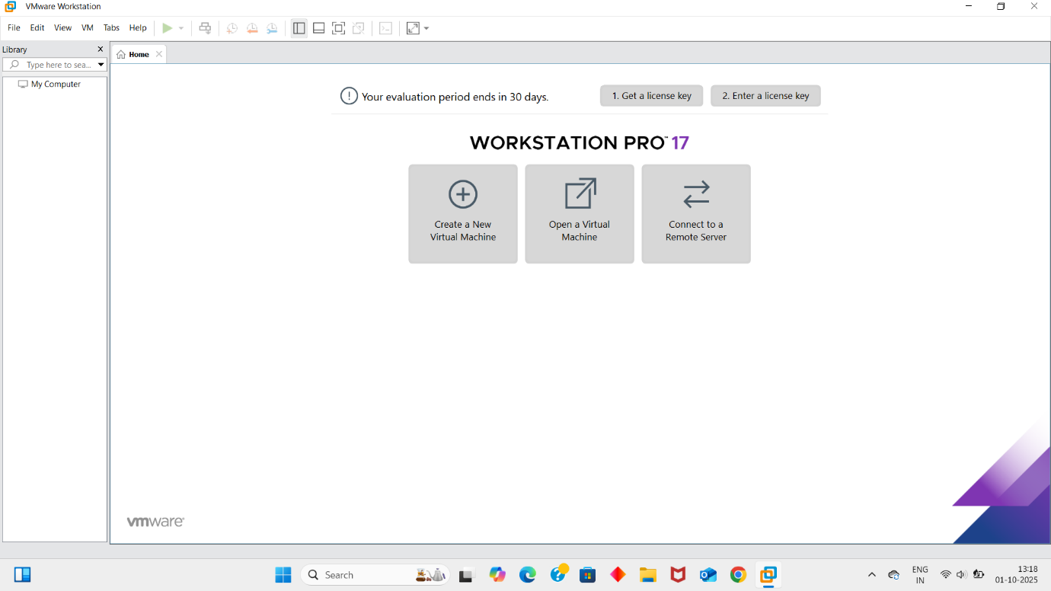

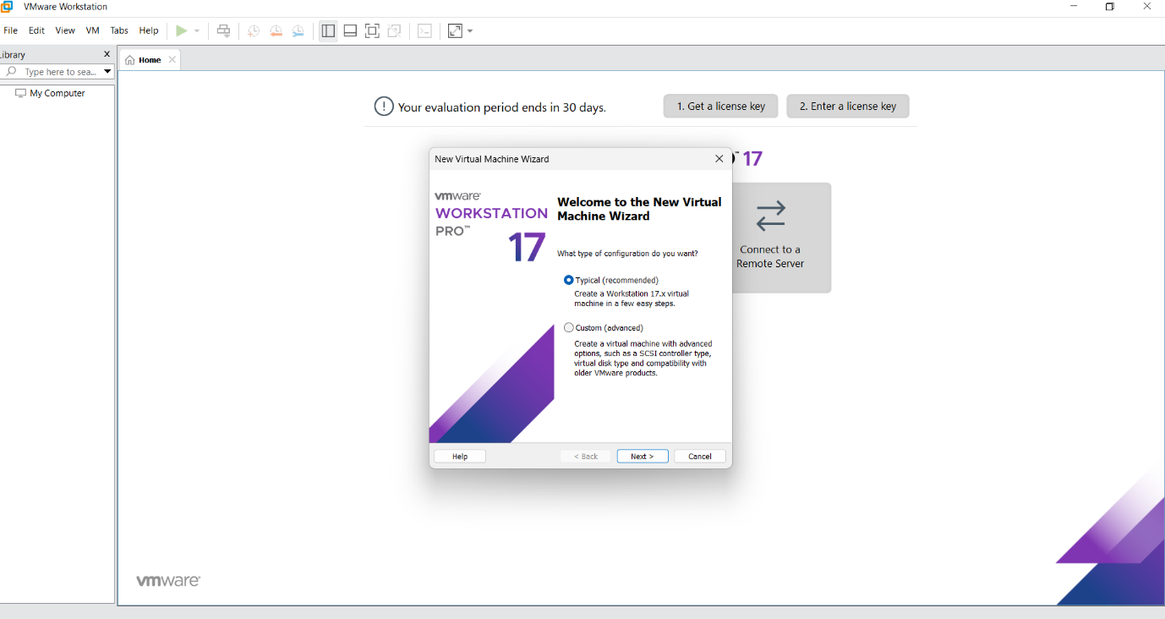

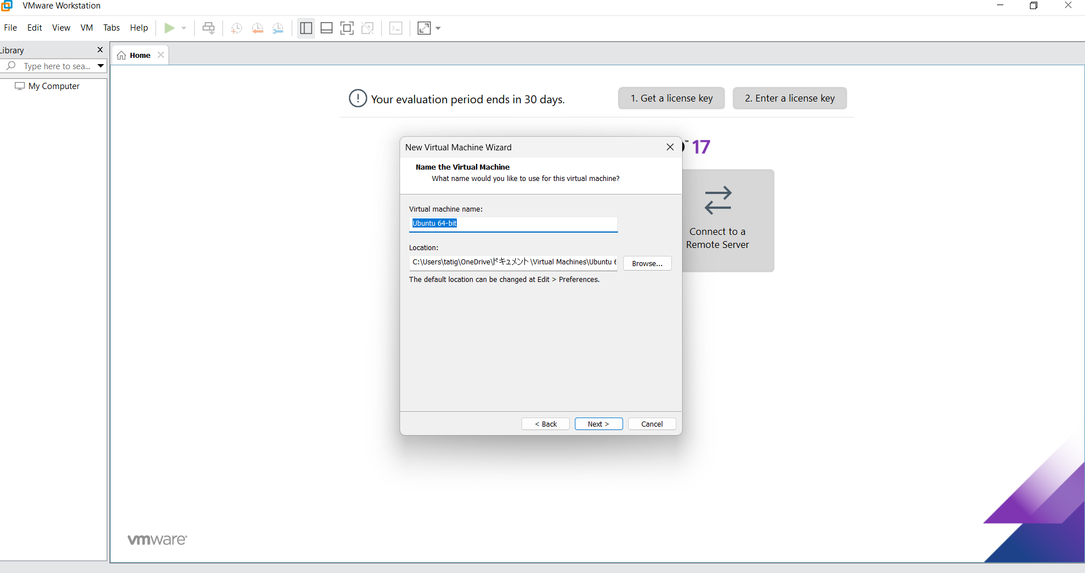

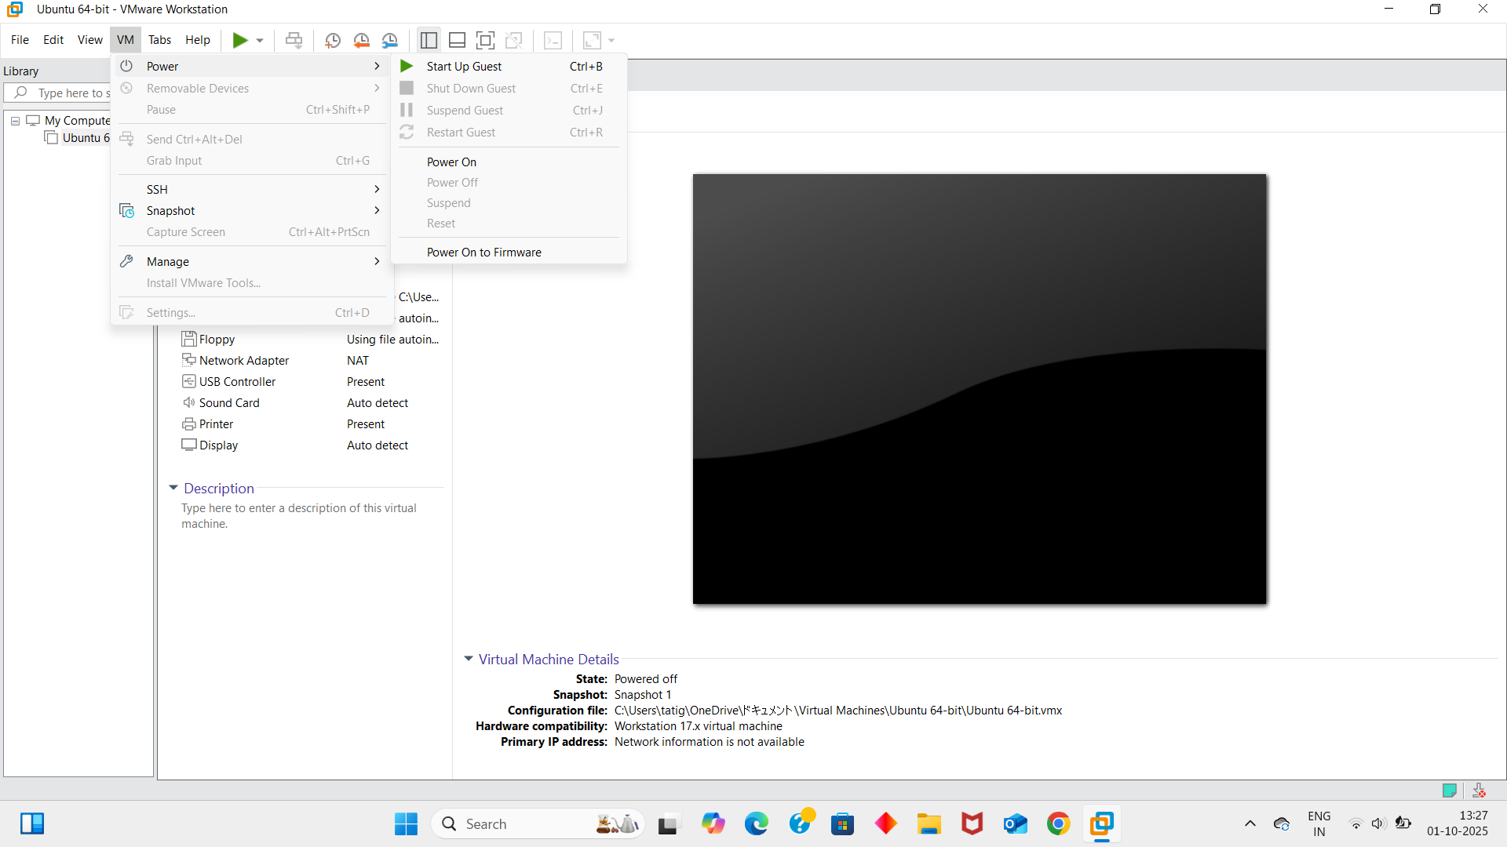

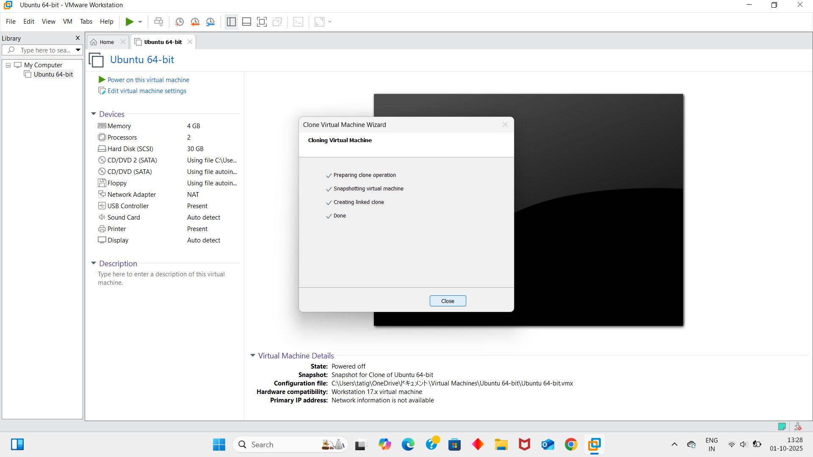

**Result:**

Thus virtualization by installing type-2 hypervisor in your device, create and configure VM image with a host operating system windows has been demonstrated.